Patty Bear-Rogalla is a hard-working and caring mother. Patty provides for her 3 children by working two jobs. As a coworker, she is known to have a story or a word of encouragement. If Patty isn’t working hard or taking care of her kids, she likes to spend her free time reading and watching movies.

In late September, Patty developed a sinus infection that just didn’t want to go away. She went in multiple times to see Dr.’s, only to be told it was a very persistent sinus infection. Unfortunately, on November 23rd 2021, Patty was admitted to the hospital with an abscess on her brain. On the same day, she was emergency air lifted to the Mayo Clinic in Minneapolis to perform her emergency surgery to remove the abscess. She stayed in Mayo for the following week missing out on celebrating Thanksgiving with her family. When released from the clinic, Patty had to take a month off of heavy duty work while she recovered. Now she is back to working hard and taking care of her kids along with a skittle pack of medications to take.

There will be a silent auction, bake sale, and $10 for a Spaghetti Dinner.
If you are not able to attend or donate, you may also send a check/money order to:

Capital Credit Union Please Make Checks to: Capital Credit Union – Benefit
204 W Thayer Ave, For: Patricia Rogalla
Bismarck, ND 58501

Let’s get together and show Patty the real meaning of “North Dakota Nice” and help her out with some of her hospital bills.

If you would like to donate anything for our silent auction or bake sale, you may bring your item(s) to the Elks Lodge. Any questions, contact Amanda at 255-1199.
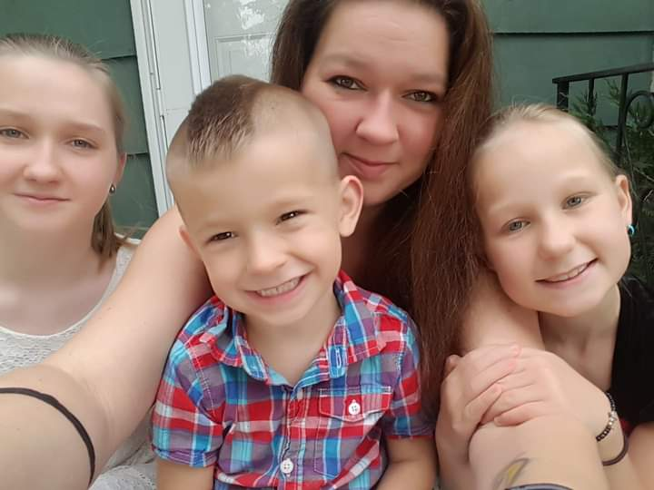
Thursday, August 25th at 5:30pm
Bismarck-Mandan Elks Lodge
(900 S Washington St., Bismarck)
Lodge Floor
(All ages welcome)

